|  |  |  |  |  |
| --- | --- | --- | --- | --- |
| TEST # | INPUT | EXPECTED | ACTUAL | PASS/FAIL |
| 1 | Goes to home page | Display home page with date/time and description | Displays homepage with time/date and navigation | PASS |
| 2 | Click About | Display of About page with picture of band. Description of band background and list of members. | Displays About page with picture of band which has been centered and sized. Description of band with list of members and a link to click to read full bio online. | PASS |
| 3 | Click Music | Display of links for different things such as music platforms. Youtube and link for latest album listen. | Displays Music page with all their links and icons to fit the clickable links | PASS |
| 4 | Click Music | refresh Page | Refreshed page | PASS |
| 5 | Click About | Goes to About Page | Went to About Page | PASS |
| 6 | Click Home | Take back to Home page | Went back to Home Page | PASS |
| 7 | Click Home | Refreshes home page | Refreshed home Page | PASS |
| 8 | About, AS(last fm icon) | Takes to Last.FM tears of mars page to read full BIO | Went to Last.FM tears of mars full Bio | PASS |
| 9 | Music, bandcamp | Takes me to bandcamp tears of mars page | Dispalys bandcamp tears of mars page latest album | PASS |
| 10 | Muisc, Spotify Icon | Goes to tears of mars spotify | Displays Spotify Tears of Mars page | PASS |
| 11 | Music, Apple Music Icon | Goes to apple music tears of mars page | Doesn’t load on my Mac. However on windows It loads the page | PASS/FAIL |
| 12 | Music, Youtube Icon | Goes to YouTube Tears of Mars page | Load YouTube Tears of Mars’ Page | PASS |

Pylint Results:

Home Page:TEST#1:

About Page Test Case#2:

Music Page Test Case#3:

Test cases 4-7 just test that the page refreshes…No image to show a refreshing page.

Test Case#8:

Test Case#9:

Test Case#10:  
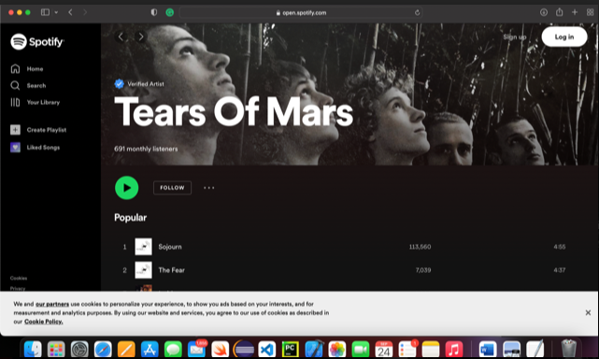

Test Case#11:  
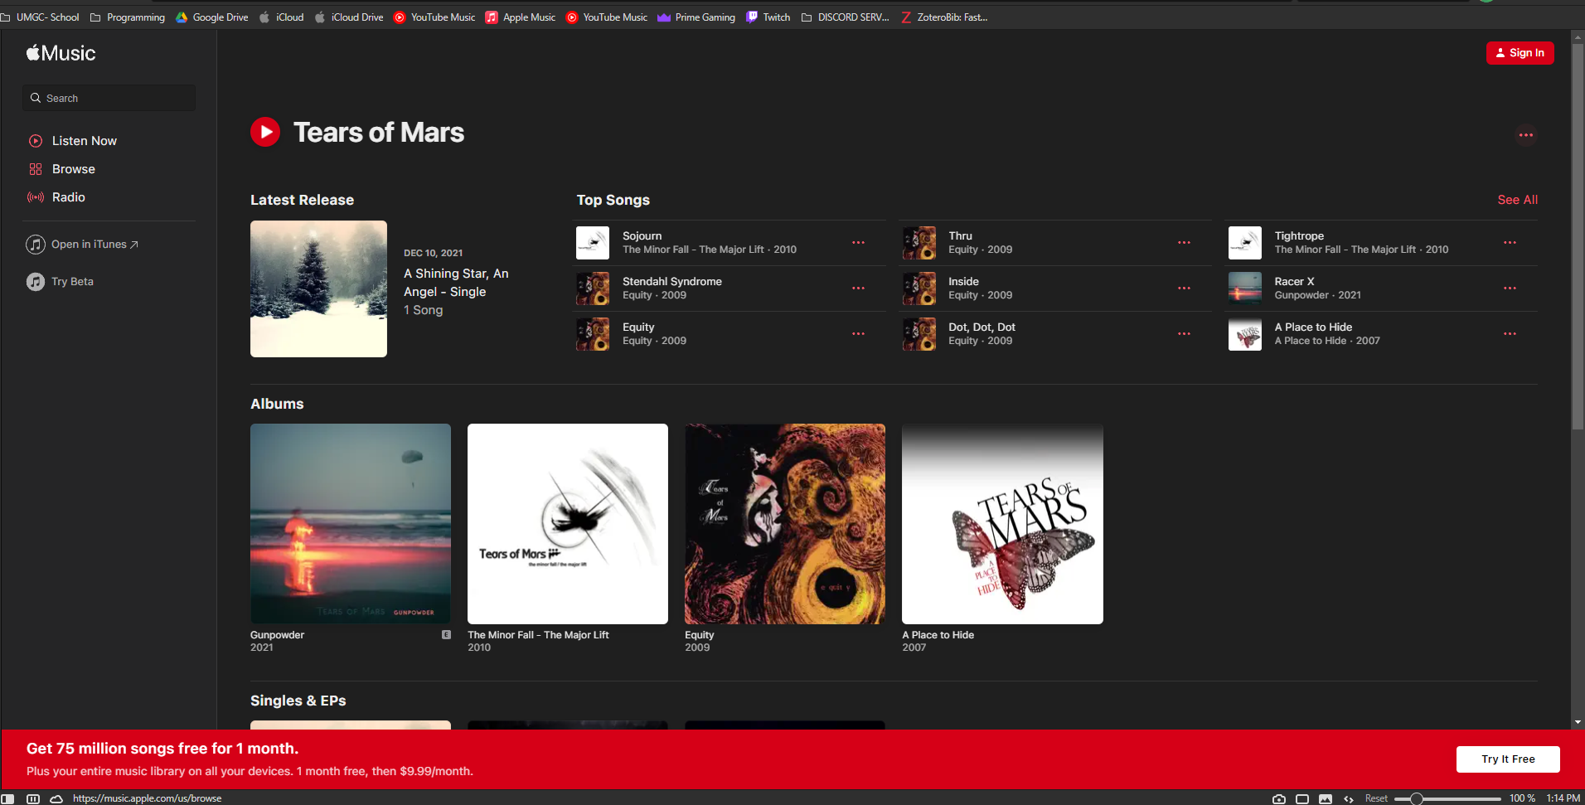

Mac it did not do anything. And on windows it is extremely slow to open apple music.

Test Case#12:  
